Zoltan Marchant

Prof. Hassebo

7/30/22

ELEC 3225-03

Group Assignment 5

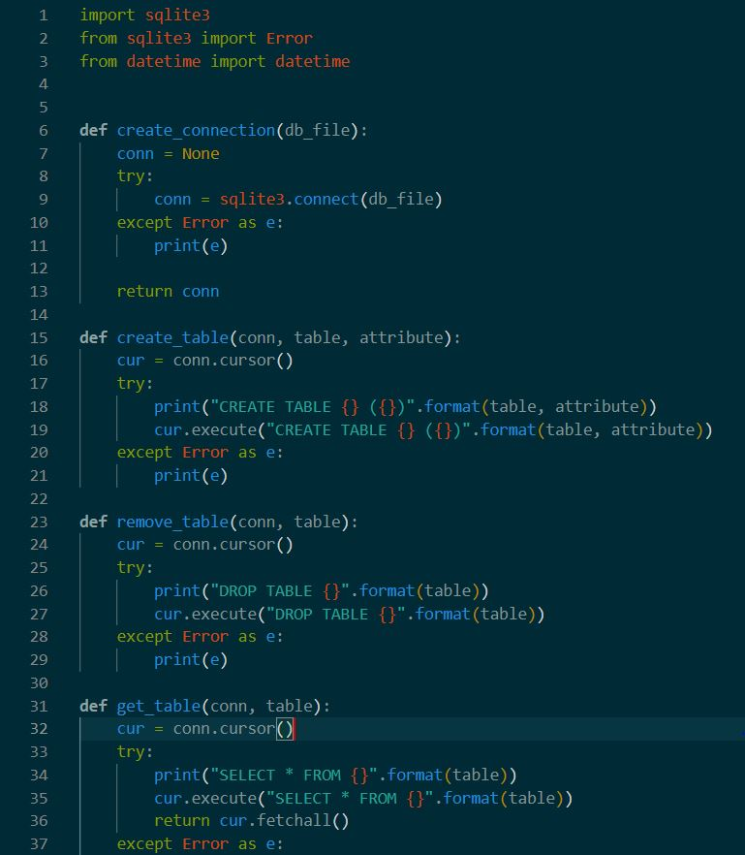

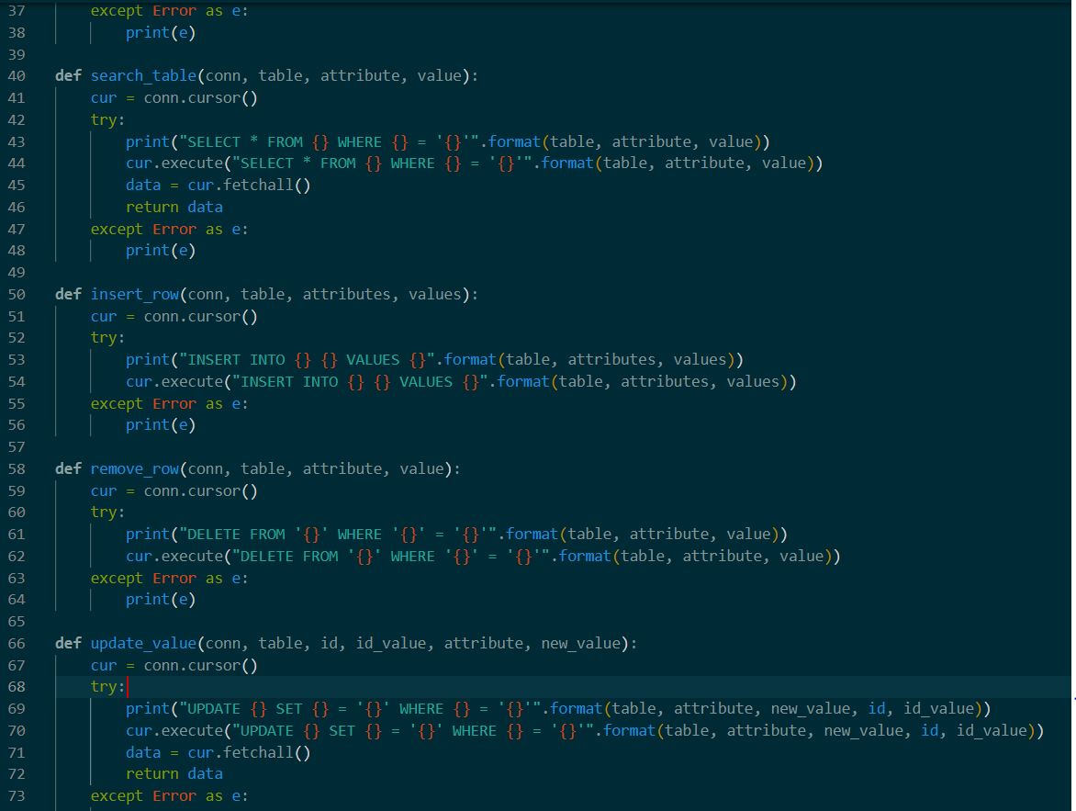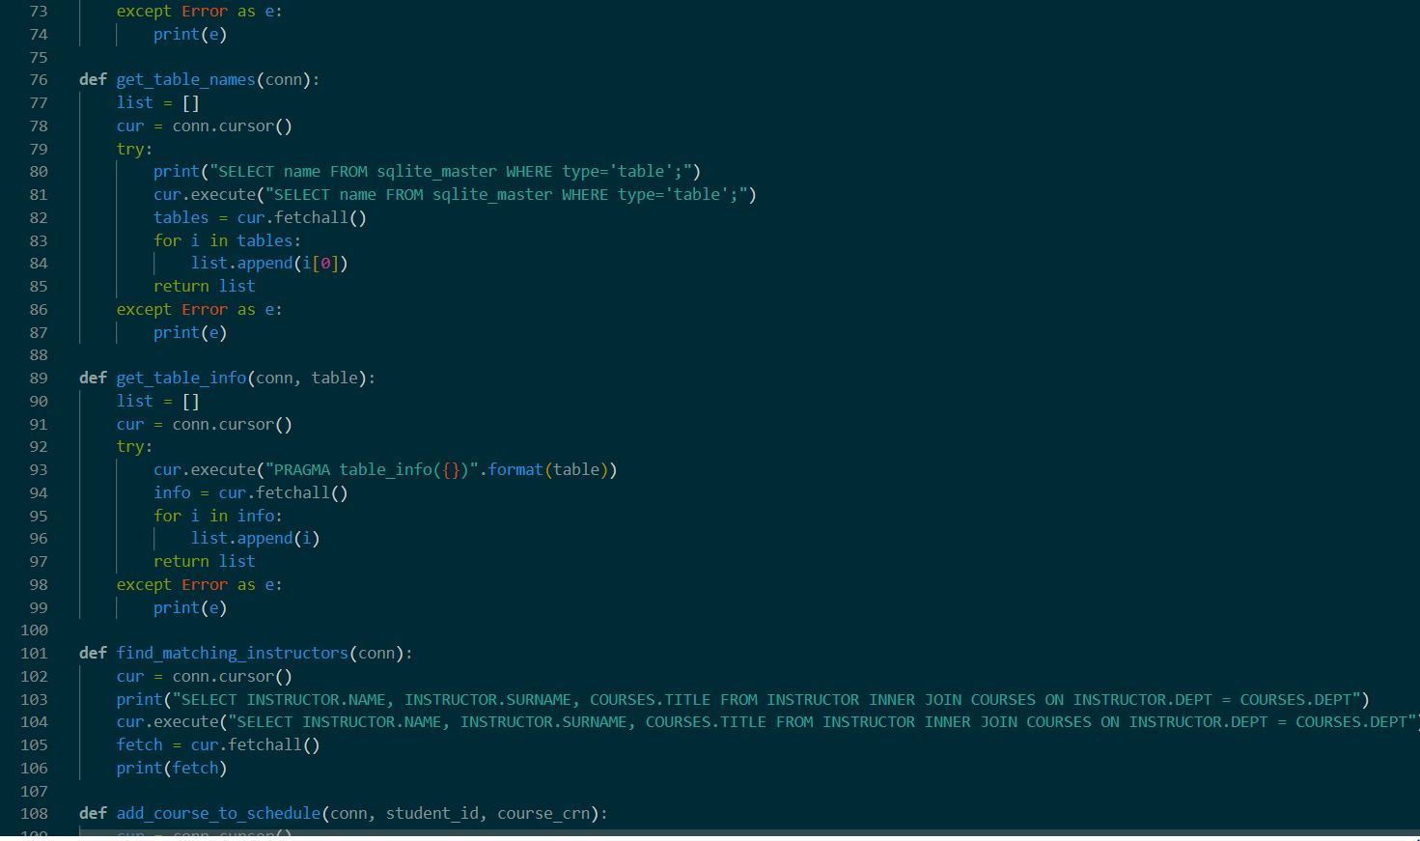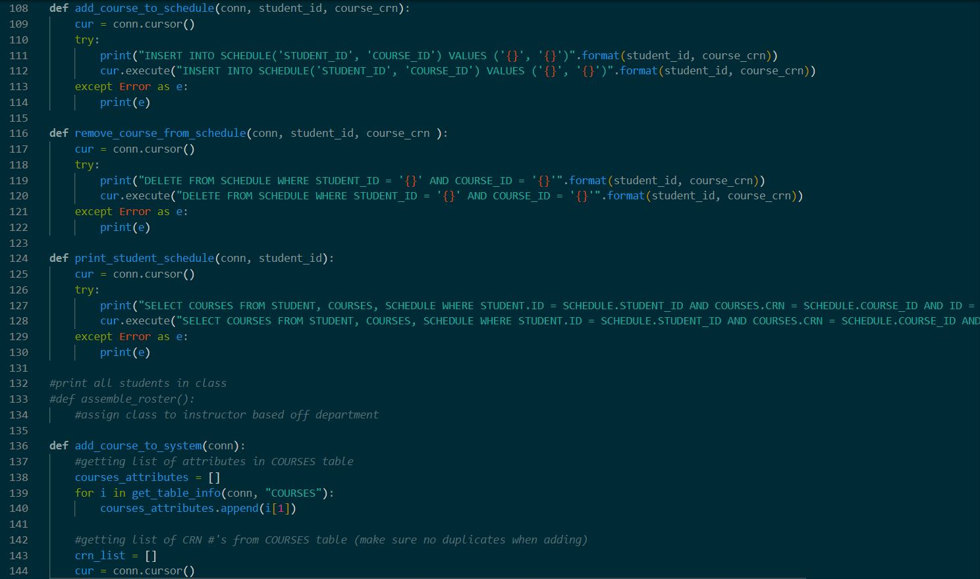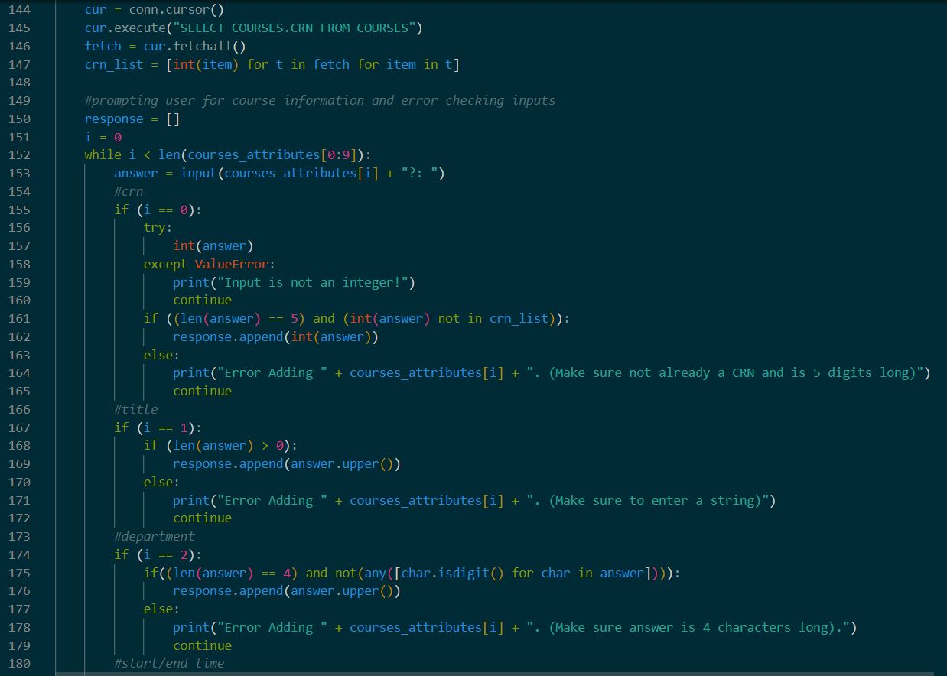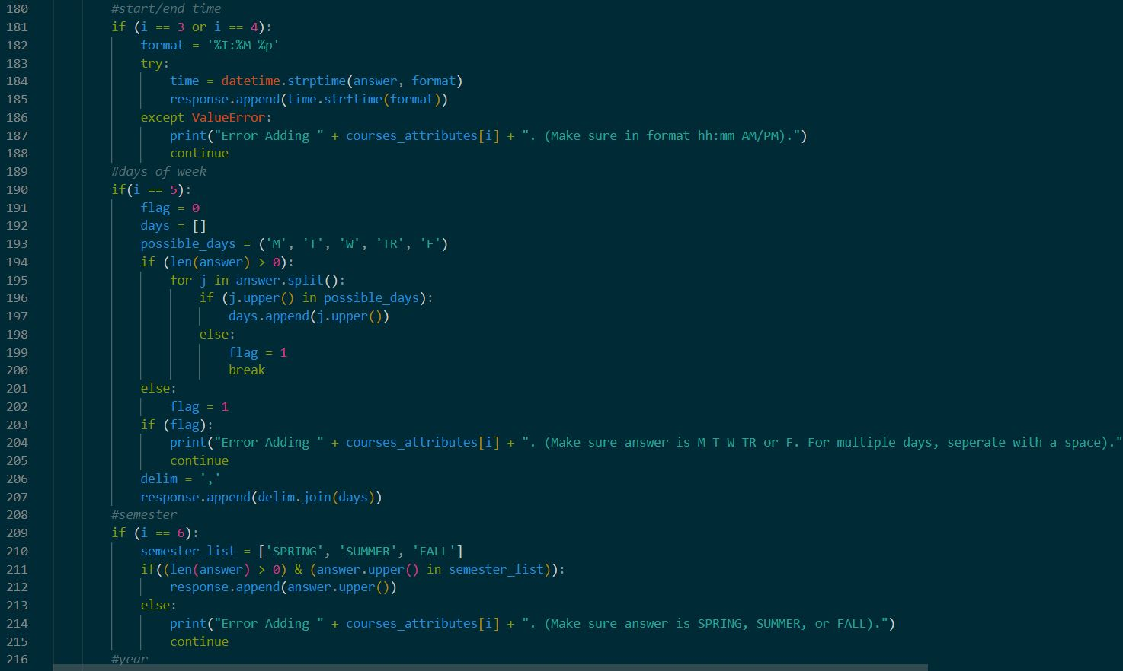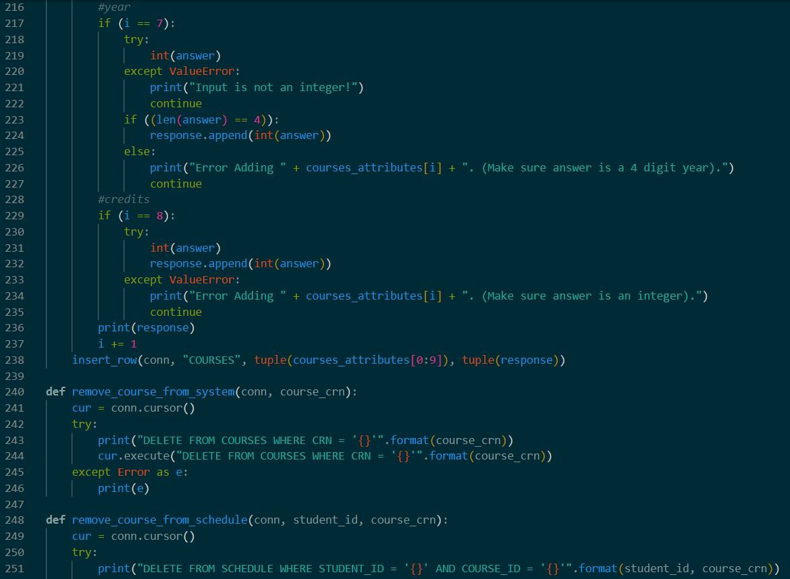

Dom predominantly worked on this, interfacing the functions to the database, while I created the shell for the functions. This was with the understanding that we would trade roles for assignment 6. The most difficult of this portion was learning concatenation in order to update the tables with the entered information. This especially included adding a course to the schedule.